A.) How to Use Individual Product Features (IPF) Files for Product Configuration
Notes:
• The IPF files have been constructed for predetermined sets of features, so that some drop-­‐down menus will allow only one choice. Drop-­‐down menus for switch action type, legend configuration data, and photometric requirements have multiple options. The IPF files also require special configuration data to be added to text boxes (filled in by default with "TBD").
• Make sure the MS-­‐Word document lock command has been enabled and is located in your quick access tool bar. The drop-­‐down menus will not work if the document is not locked. Go to the "Review" tab and click on "Restrict Editing" to enable lock command.
• Please email completed IPFs to our engineering group at korry.techinfo@korry.com. For assistance please e-­‐mail us at the same address.

a. 389 5-­‐Pin and 6-­‐Pin IPFs (Reference Drawings D41861 and D44258) – Input and Selections. See Figure 1 for assembly configuration.

• The instructions below are for both NVIS and Non-­‐NVIS IPFs. All NVIS
selection fields are noted and are only required for the NVIS IPFs.
• Flip guards and crimp pins are ordered separately.
• Korry will assign the dash number, following the five digit part series
number, for each configuration.
• 389 5-­‐Pin provides for a higher current carrying capability and wire size than the 389 6-­‐Pin. The extra pin allows for an additional power or ground connection.

Figure 1 – Quick Switch Mounting Configuration
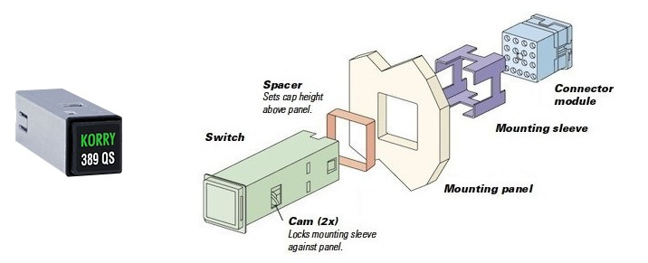

1) Mounting Panel Thickness (Ref)
➢ The mounting panel thickness is the sheet metal thickness value used for
mounting the switch. Generally that thickness is between 0.062 and 0.125 inches. Type in the value of the mounting panel thickness. Universal sleeve range of 0.032 to 0.400 inches.

2) Spacer
➢ The input into the spacer field is the requested spacer thickness. The spacer thickness sets the height of the switch cap assembly above the mounting panel. Generally the spacer is used to account for a 0.250 thick lightplate located around the switch. If no spacer value is provided the top of the switch cap will be approximately 0.140 inches above the mounting panel. Type in the value of the spacer thickness.

3) Switch Action Type
➢ The switch action can be Momentary Action, i.e. after pushing down on the cap and releasing it the cap returns to the original position; Alternate Action, i.e. after pushing down on the cap and releasing it, the cap stays down. Pushing the cap down again and releasing it, the cap comes back to the full up post original position; or Indicator (Non-­‐switching), no cap movement when pushed down. Select one of the three options.

4) Legend Nomenclature
➢ Type in the legend nomenclature for each section of the legend. For multiple lines separate each line with a comma. If no legend is required type in (Blank).
Note: Dependent upon the font type and font size chosen, the legend configuration will only allow a limited number of characters per line and/or per legend.

5) Legend Type
➢ Select the type of legend for each legend segment. Figure 2 details the ON and OFF characteristics for each legend type. All legends are readable in direct sunlight except N (2G2).

Figure 2 – Legend Types
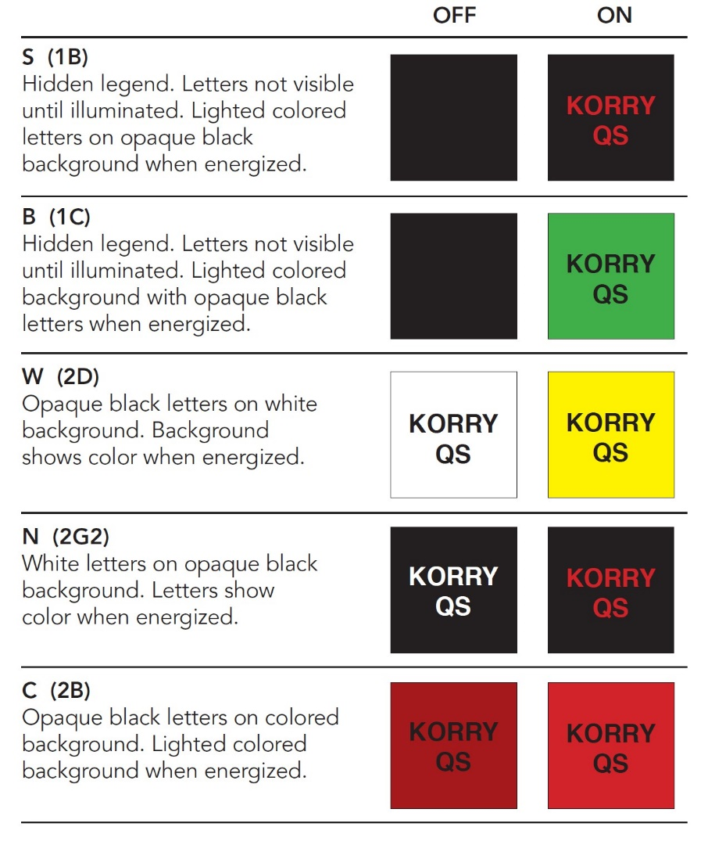
6) Font Type
➢ Select the font type for each legend segment. FM = Futura Medium, FMC = Futura Medium Condensed, GN = Gorton Normal, GC = Gorton Condensed.

7) Font Height
➢ Select the font height for each legend segment.
Note: Combinations of font type and font height may not fit into the legend segments.

8) Illuminate Color
➢ Select the illumination color for each legend segment.

9) NVIS Type, Class (NVIS IPF Only)
➢ Select the type of NVIS viewing equipment that will be used to view the NVIS
switch.
Note: Type I NVIS goggles are direct view goggles used primarily on rotary aircraft. Type II goggles have both NVIS

and normal lighting views (Cat’s Eye) used primarily on fixed wing aircraft. Types I, Class B and Type II, Class A are not typically used.

10) Photometric Requirements
1. Non-­‐NVIS Photometrics
➢ Select the photometric requirements for each legend segment. The photometric characteristics are based upon the type of legend chosen. Table 1 details the selections that need to be chosen for each legend type. All legends are readable in direct sunlight except N (2G2). Contrast only applies to sunlight readable legends.
Table 1 – Non-­‐NVIS Photometric Requirements

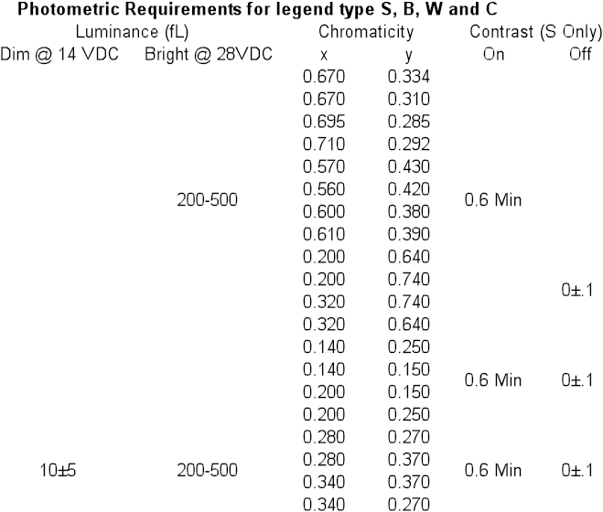
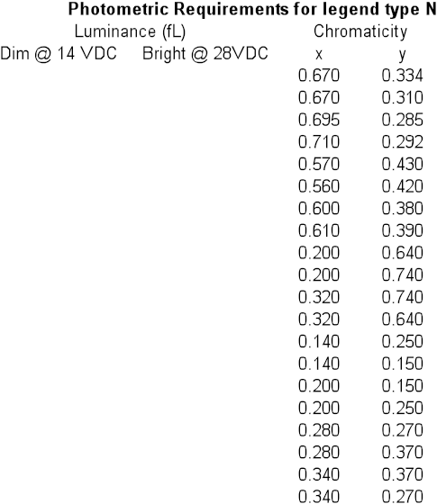
.

2. NVIS Photometrics
➢ Select the photometric requirements for each legend segment. The photometric characteristics are based upon the type of legend chosen and the type of NVIS equipment used to view the legend. Table 2 details the selections that need to be chosen for each legend type. All legends are readable in direct sunlight except N (2G2). Contrast only applies to sunlight readable legends.

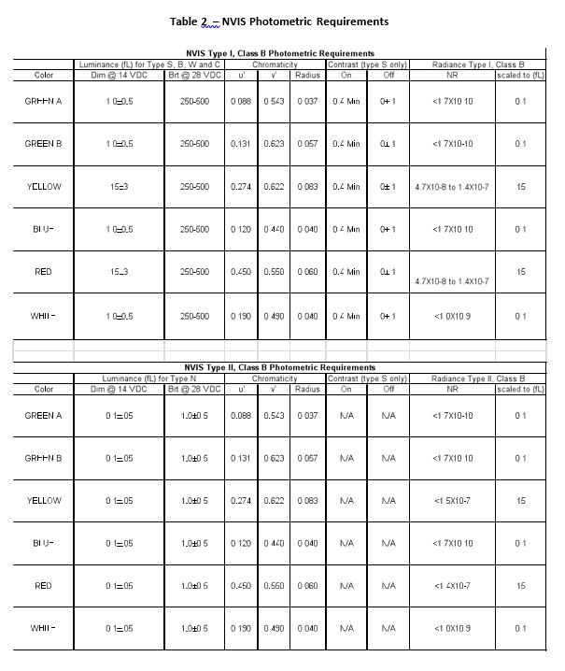

Table 2 (con't)- NVIS Photometric Requirements

NVIS Type I, Class A Photometric Requirements
 | Luminance (fL) for TypeS, B, Wand C |  | Chromaticity |  |  | Contrast (t IPe S only] |  | Radiance Type I, Class A
Color | Dim @ 14 VDC | Brt@ 28VDC | u' | v' | Radius | On | Off | NR | scaled to (fL)
GREEN A | 1.0±0.5 | 250-500 | 0.088 | 0.543 | 0.037 | 0.4 Min | 0±.1 | <1.7X10-10 | 0.1
GREEN B | 1.0±0.5 | 250-500 | 0.131 | 0.623 | 0.057 | 0.4 Min | 0±.1 | <1.7X10-10 | 0.1
YELLOW | 15±3 | 250-500 | 0.274 | 0.622 | 0.083 | 0.4 Min | 0±.1 | 5X10-8 to 1.5X10-7 | 15
BLUE | 1.0±0.5 | 250-500 | 0.120 | 0.440 | 0.040 | 0.4 Min | 0±.1 | <1.7X10-10 | 0.1
RED | 15±3 | 250-500 | 0.450 | 0.550 | 0.060 | 0.4 Min | 0±.1 | 5X10-8 to 1.5X10-7 | 15
WHITE | 1.0±0.5 | 250-500 | 0.190 | 0.490 | 0.040 | 0.4 Min | 0±.1 | <1.0X10-9 | 0.1

NVIS Type II, Class A Photometric Requirements
 | Luminance (fL) for Type N |  | Chromaticity |  |  | Contrast (t (pe S only] |  | Radiance Type II, Class A
Color | Dim @ 14 VDC | Brt@ 28VDC | u' | v' | Radius | On | Off | NR | scaled to (fL)
GREEN A | 0.1±.05 | 1.0±0.5 | 0.088 | 0.543 | 0.037 | N/A | N/A | <1.7X10-10 | 0.1
GREEN B | 0.1±.05 | 1.0±0.5 | 0.131 | 0.623 | 0.057 | N/A | N/A | <1.7X10-10 | 0.1
YELLOW | 0.1±.05 | 1.0±0.5 | 0.274 | 0.622 | 0.083 | N/A | N/A | <1.5X10-7 | 15
BLUE | 0.1±.05 | 1.0±0.5 | 0.120 | 0.440 | 0.040 | N/A | N/A | <1.7X10-10 | 0.1
RED | 0.1±.05 | 1.0±0.5 | 0.450 | 0.550 | 0.060 | N/A | N/A | <1.5X10-7 | 15
WHITE | 0.1±.05 | 1.0±0.5 | 0.190 | 0.490 | 0.040 | N/A | N/A | <1.0X10-9 | 0.1

b. 427 and 428 IPFs (Reference Drawings D17479 and D20695) – Input and Selections.
See Figure X for assembly configuration.
• The instructions below are for both 427and 428 IPFs. Some selections have been identified for input on either the 427 or 428.
• Korry will assign the dash number, following the five digit part series number, for each configuration
• Flip guards and crimp pins are ordered separately

1. Chromalux Series
➢ Select the assembly type 427 or 428 product.

2. Switch Configuration
➢ Select the type electrical interface, i.e. poke home connector for wired crimp socket or solder turret for soldered connection.

3. Mating Crimp Socket (for Poke Home)
➢ Select the size of the crimp socket pin, i.e. 20 gauge or 22 gauge (solder turret interface is NA).

4. Mounting Style
➢ Select the mounting style, i.e. poke home connector or solder turret.

5. Mounting Panel Thickness/Range (Ref)
➢ The mounting panel thickness is the sheet metal thickness value used for mounting the switch. Generally that thickness is between 0.062 and 0.125 inches. Type in the value of the mounting panel thickness.

6. Assembly Type (428 Only)
➢ The assembly type for 428 has only one option.

7. Lamp Circuit
➢ Select the type lamp circuit for the electrical interface and for the type of display required.

8. Switch Action
➢ Select the type of switch action required or an indicator option for the 427 product.

9. Base Type
➢ Select the type of base required, pokehome or solder turret.

10. Switch Circuit (428 Only)
➢ Select the type of switch circuit identification required.

11. Pin-­‐Out Type (427 Only)
➢ Select the type of lamps circuit pin out jumpers required.

12. Jumpers
➢ Determine if jumpers will be required.

13. Switch Contract Material/Rating
➢ Select the type of switch material based upon low current (less than 1 amp)
or high current (greater than 1 amp).

14. Cap Type
➢ The high efficiency cap is the only cap available for the Quick Switch.

15. Lens Config (See Sheet 9)
➢ Select the type lens configuration, Full, Split, 3-­‐way or 4-­‐way (427 only).

16. Legend Nomenclature
➢ Type in the legend nomenclature used on each segment.

17. Legend Type (Table 1)
➢ Select the type of legend type.

18. Illuminated Color
➢ Select a legend color below. All 427 and 428 colors are per MIL-­‐PRF-­‐22885.
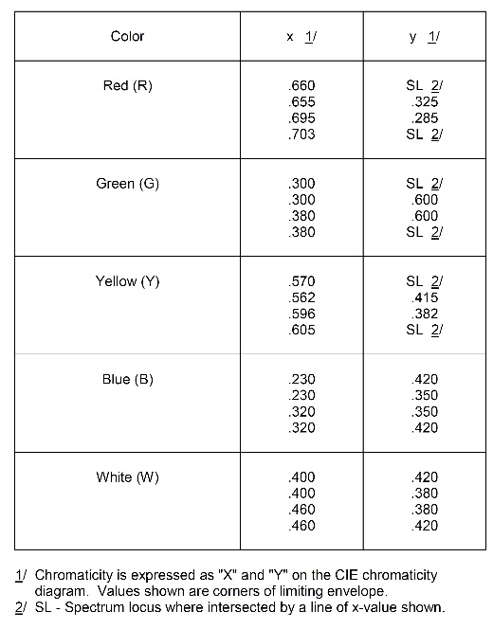

Table 3 – 427 and 428 Chromaticity Values

19. Lamp (Voltage)
➢ Select the lamp voltage.

